4

A SPECIAL DAY.

On a Friday in October, I was among a group of collectors of engines, cars, and tractors that accompanied Jim Rush to Columbus, Indiana to the Cummins Museum. Jim was invited by a group of engineers who volunteer their time to restore old and unusual Cummins motors in all types of things.

As they day went on, it was evident the respect they had for Jim’s knowledge and his abilities. As we well know, he can fix anything, and they know that too. We had a guided tour of the museum. The engineers told us about each exhibit and allowed us to ask questions for as long as we wanted. We were also went go to a building where they worked on the restorations and where experimental motors were housed. At the time, they were in process of restoring two of the Cummins powered cars that had run in the Indy 500. One of them was a two seater, one for the driver and one for the mechanic.

I was quite impressed to see that they were impressed with both Jim and his collection of engines, and he had a long-standing connection because of this. Those of us who went have known Jim for many years and were glad to see him recognized for his talents and collection.

It was a great day for all of us, and one I will not forget. If you get a chance, talk to Jim about his collection, it is good one.

Max Jennings

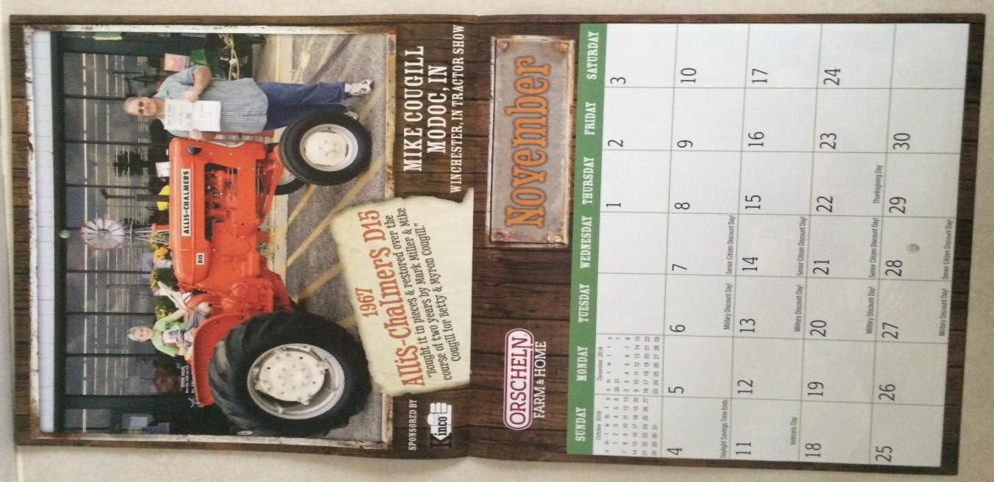
Congratulations!
3

Greetings! Everyone,

Winter is quickly approaching, and it’s becoming less enjoyable to be outside having fun. It seems that with every new year the thought of winter becomes just a little more foreboding, so I will make an extra effort to think back to all the fun and blessings throughout this past year. As my mind goes rolling back though time, I am bombarded with all that we have done so far. We have been blessed in so many different ways in every event or occasion, and so very much to be thankful for, especially as the Holiday season approaches.

Recently, the pastor’s message included a reminder that much will be required of the person to whom much is given. One of the greatest riches that I possess is my family and friends. I am one of a family of three girls and two boys, and we have always been a close knit family and have always enjoyed getting together. We attempt to have our sibling gatherings on a monthly basis and we just had an early Thanksgiving celebration with all five of us together along with our families. We had a great time as usual, but as the saying goes,” things are a changing”. As we get older
(as you know, we are already old and getting older), some of us are facing some health issues that will get progressively worse. But, when we love and care for others, the process of caring and having empathy for each other can become downright painful.
The same is true with our circle of friends. As an example, is the recent tornado that stretched from southwest of Dunkirk all the way to northeast of Portland and did great damage to the homes and property of many, many families that I know. The majority of those people are longtime friends and neighbors from the community where I grew up and then worked for many years. My entire heart and soul ached as I thought and prayed for them and their situation. However, there is a bright side to all of this to remember, none of them were seriously hurt.

In order to survive our richness of possessing such a wealth of family and friends, we really need to spend much time remembering and appreciating the good times and celebrations. However, we need to do what we can to help others through their struggles and use our wealth of family and friends to help with the pain and heartbreak as we strive to do what we know is right.

A couple note worthy things to celebrate in the club, the 50th wedding anniversary of Merritt and Rita Freer, and the awesome group of farmers who brought in the harvest for Joe Hottinger’s family. Two different types of thankfulness and celebration, but sharing our wealth of family and friends never the less.

Hope you had a Happy Thanksgiving,

President, Joel Taylor
.

It is rumored that many of our members and friends have added to their collection s. There are too many to mention on rumor, but we know we will all know soon! Projects and ideas are plentiful for the clubs future, as members, as well as the officers and directors plan for the future. There will not be another meeting until January 18, 2018, think of all they will have to share by
then!
Start planning to show off these new
projects and additions at Cabin Fever
Day. It will be March on March 24,
2018. That is your deadline to get ready.

Connie’s Take on Things 2

And it was the hottest plow day ever, really it was. But that did not stop a thing, 12 or 15 tractors came to play, but I lost a sure count because they came and went and changed drivers. Darrel Hazelbaker drove the new shuttle wagon around the field until he had no riders because of the heat. We did have shade at the edge of the field and plenty of water. But that was probably negated with the hot soup we had for lunch, and hot ham sandwiches too. I certainly didn’t think it was going to be so hot, but we ate it just like it was cold weather, maybe because it was just plain good. In my defense, the soup was left over from the September meeting (another hot day), when George Chalfant cooked soup over a fire. Having lived in Indiana all my life, I know you cannot predict the weather, so we just deal with it! It was another great day, thanks to John Smith for allowing us to
plow his field and being a friend to RCAC.

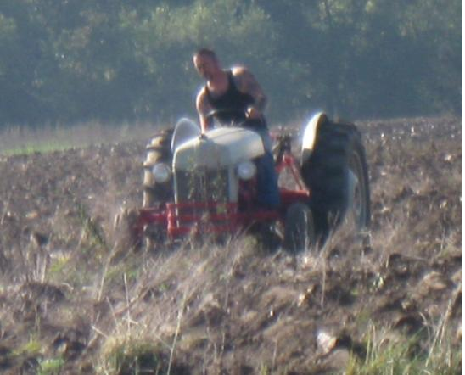Trent Snyder. This is not the tractor he had at Orscheln, I am sure that one has never plowed.
The field was on Hwy 28 East of 300
East, but Wayne McGuire and Bobby Cassel toured the western side of the county looking for us. Oh and that’s
not their only tour this year, they had
a very nice drive on their tractors while looking for Huntsville too. Oh well, I have brain fog, I understand it! I have stopped apologizing for it, but that doesn’t stop the looks I get. Everyone will understand
someday, won’t they.

A group from the club did a community service event, several attended the Huntsville Community Center hog roast benefit, they were raising money to paint the inside of the Center. Many of our members are from that area and it is good to support them and the Center. They did raise enough money for their project, it
was good to help them, and everyone enjoyed the fun and friendship. And, we had a nice display of tractors
and cars to add to the day.

In an effort to continue supporting our county, the club has purchased a shuttle wagon. The plan is to use it to
shuttle folks between our
grounds and the 4-H grounds. This is a new endeavor for the club and the hope is that we do a better job of serving both
our members, those involved
with 4-H. and those who visit both events.

The club supported club member, Jeff Boyer, as he organized the 100th year celebration of Davis-Purdue Farm by staging a small tractor, equipment, and antique car display for the event. Many of the club members attended the events, giving rave reviews to the celebration.
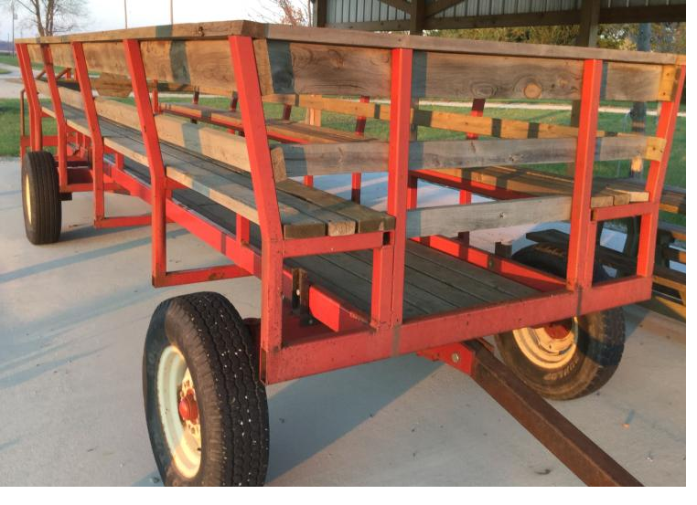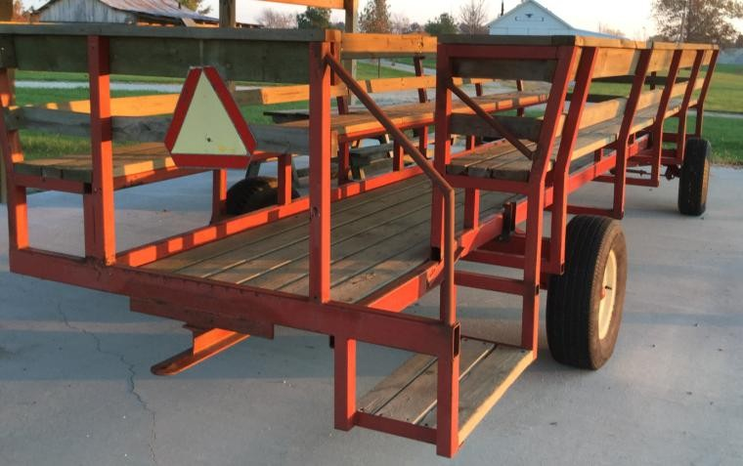

Notice the low step and hand rail for easy access, and sturdy seats with backrests. Thank Squeek for finding the wagon and following thru with acquiring it for the club. Thank Tom Swingley for adding the handrail to make it safer to step up on the wagon.
1

The Orscheln Show.

We don’t know if we have a calendar
entry yet, but we do have a winner.

Mom and Dad, Myron and Betty Cougill, purchased the D-15 in early 2000 from an individual on County Line Road near Economy, IN. They arranged to pick it up over the 4th of July weekend. When we arrived there were parts scattered throughout the barnyard. My sister, Michelle, and I were able to get the front axle and frame bolted to the rear end and finally got that loaded onto the trailer. The engine block and all the internal parts were junk, so we took what we had to
the house. Dad looked for a block for quite awhile and finally located one thru Jim Osterholt.

In 2015, Mom decided that it was time to get the ball rolling on this project. She asked if I was interested in helping and, of course, I said yes. Eventually it ended up at Old Barn Repair Shop where Mark Miller and I started the restoration between other jobs. Over the span of almost 2 years, it was finally completed, but not without struggles. I was working on a different color and parts for a D-15 are scarce, both
original and after market. It was finished just week before the RCAC show this year. Mom did not get to see the finished product in person, but had pictures to make sure everyone
saw it and knew how proud she was of it. Her comment
would always be, “Isn’t that the most gorgeous tractor.”
Mike Cougill and Lane displayed this beautiful tractor belonging to Mike’s mother Betty and won 1st place. You can see that it is deserving of a calendar page.

2nd place was Bill Hinshaw with his beautiful Oliver, another great restoration.

3rd place was Trent Snyder with Bruce’s hot rod Ford, so much talent in the club.

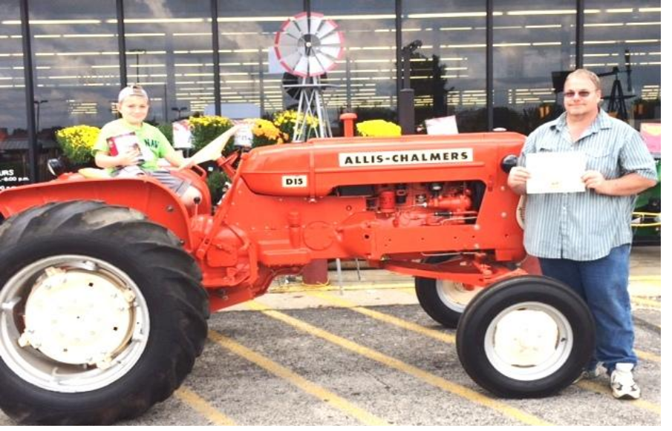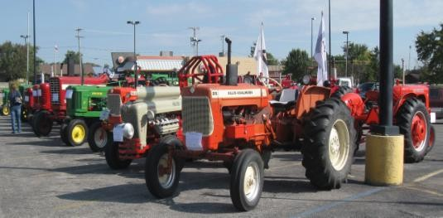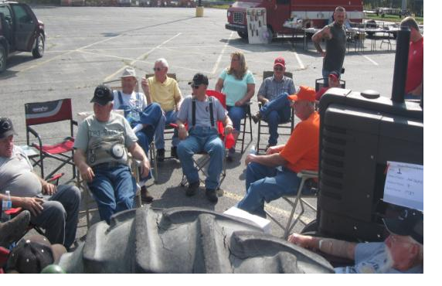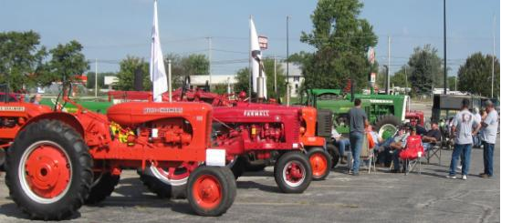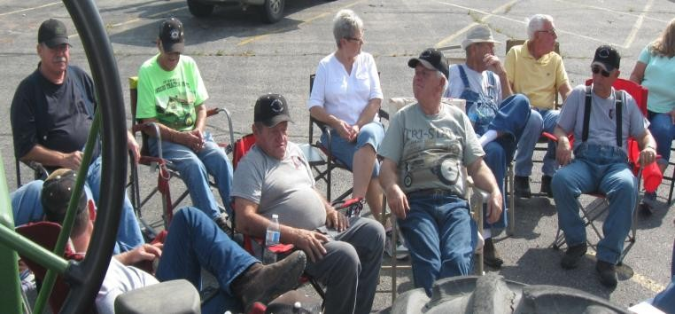Mike Cougill

Don’t you just love stretched pictures, so slimming, an illusion for sure.

We love to visit, it was a hot day, hot pavement, hot tractors, but no one thought to bring a canopy.

